

  - Introduction to the Software easyNWK 2.0.4
  - User manual

Autor*innen: Alexander Rind / Julia Böck¹ / Johanna Punesch¹ / Hannah Schrenk¹ / Sarah Schweiger¹

Content management
1 Access 3
2 Start and menu 3
3 Creating a NWK 3
3.1 Determine ego 3
3.2 Add Contacts 4
3.3 Editing and Deleting Contacts 5
3.4 Editing relationships of contacts 5
3.5 Quick creation of contacts in the graphic 5
4 Saving and Opening 6
4.1 Saving a network map 6
4.2 Opening a Network Map 6
4.3 Load Demo 6
4.4 Print / Save as PDF 6
4.5 Export 6
5 Key figures 7
6 View settings 7
6.1 Anonymise 7
6.2 Horizons on 8
6.3 Connections off 8
6.4 Contact names off 8
7 The selection rectangle 8
7.1 Selection an area 8
7.2 Creating cliques 8
7.3 Zooming 8
8 Storage location and data protection 8

Access
EasyNWK 2 is freely accessible as a web application. To access the programme, simply call up the website https://www.easynwk.com/ via the web browser (e.g. Chrome, Firefox).

The easyNWK 2 is currently under continuous development. Therefore, there may be minor differences between the illustrations in the manual and the current application. Newer functions are partially not yet described.

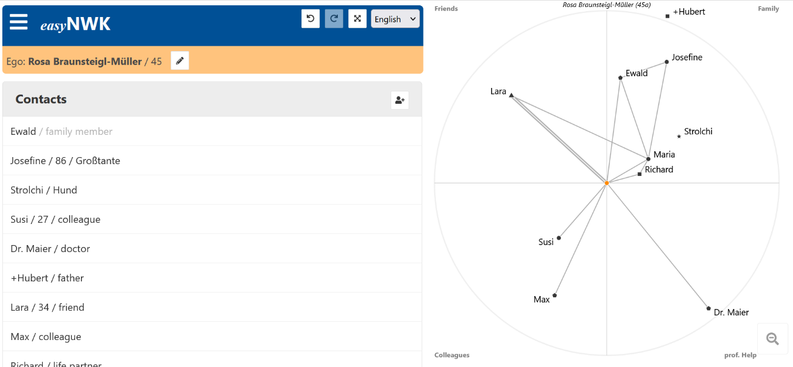
Illustration 1: Usage easyNWK with demo data

The web application can be used from different devices (PC, laptop, tablet, smartphone, ...) and independent from the operating system of the device. The layout adapts to different screen sizes and formats (portrait or landscape). Landscape format on screens of at least 10 inches is recommended. Touch screen operation is also possible.

Start and menu
As soon as the program is opened, the creation of a new network map can be started. Clicking on the symbol with the three horizontal lines/ burger menu at the top left corner opens the menu through which additional options can be reached.

With the arrow symbols at the top left, one or more steps can be undone or restored during the creation of the network map.

Next to the arrows, right beneath your search bar you may spot a box with a language displayed in it. If opened, you now may choose between English or German.

Creating a NWK
To create a new NWK, write in the empty dialogue "Ego" on the start page. If a map is already loaded, you can also click on the first item "New NWK" on the menu to create an empty NWK.

Attention: By creating a new NWK, all previously entered, unsaved data disappears. In an emergency, however, you can press the "Undo" button at the top left to return to the old NWK.

Determine ego
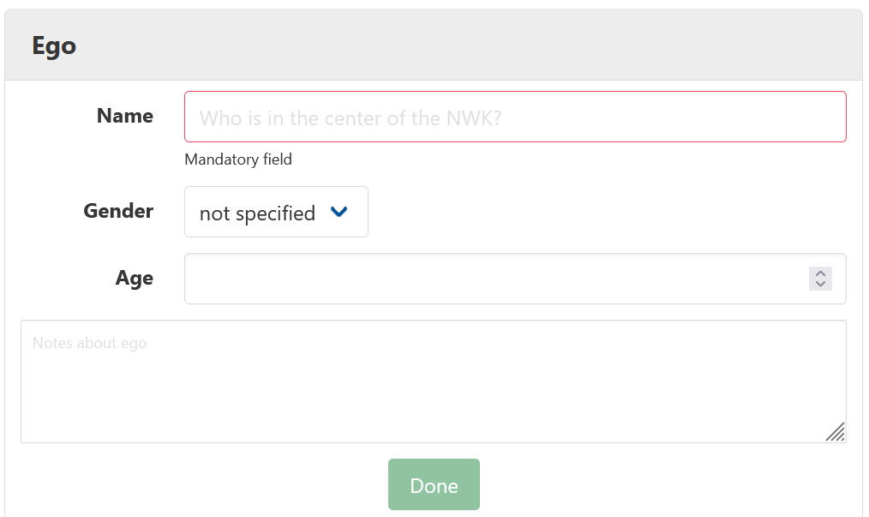
In order to start the creation of an NWK correctly, the ego of the network must be defined. The ego is the person whose social network is to be recorded. It is shown as an orange node in the middle of the network.
Illustration 2: dialogue box ego

To do this, enter the name of the ego in the first field. This field is mandatory; if it is left blank, further work on the NWK is not possible.

If desired, further personal information about the ego can be entered. By clicking on the text field next to the item Gender, gender options such as "female", "male", "diverse" or "not specified" can be selected. The age can be entered by clicking on the text box below.

The last text box offers space for notes. Depending on the need, further information such as place of residence, occupation, reason for the consultation, etc. can be noted here.

As soon as all the desired information on the ego has been entered, click on “Close” and the information it is automatically transferred to the NWK and further editing can be continued.

Subsequent changes or additions to the data are possible by clicking on "Edit ego" next to the name of the ego.

Add Contacts
In the next step, the contacts of the ego are entered using the option "Add contact". Clicking on this icon opens a menu window that allows you to add a contact.
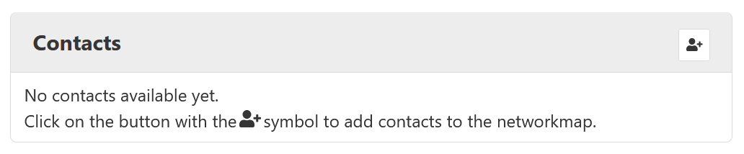Illustration 3: Add contact icon

The name of the person is a mandatory field here; without this entry it is not possible to save the contact.

The position of the person in the graphic representation of the NWK must also be defined. The graphic is divided into four equal sectors - "family", "friends/acquaintances", "colleagues" and "professional helpers". By clicking on the appropriate point on the graphic, the person is entered there as a node.

The other form fields are optional and do not need to be filled in.
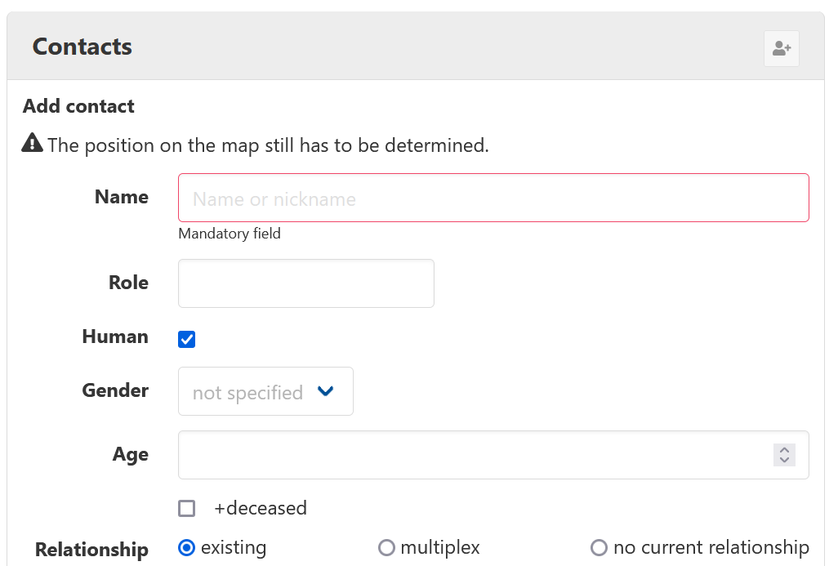
Illustration 4: dialogue box for adding a contact

Below the name text field is the attribute, Role. Clicking on the text field opens a list of selectable relationships with the ego. You can also write directly into the text field to create individual roles or to search for existing terms more quickly.

If the contact entered is a pet, the tick must be removed from the item "Human". Non-human contacts are displayed but cannot be connected to other people and are not taken into account in the key figures.

Entering gender and age works in the same way as for the ego. Additionally, a tick can be set here if the contact is deceased.

Finally, the current relationship between the ego and the added contact can be entered. By default, the program selects the option "exists", which automatically enters an edge to the ego. This can be changed with a click on one of the other two options.

At the bottom, there is again a note field for documenting further information.

Click on "Close" to close the contact and add it to the list of contacts. To add further contacts, "Next contact" should be selected. This saves the current contact and opens a new edit box with empty fields. The "Cancel" button cancels the entry of a contact.

Editing and Deleting Contacts
In order to add or change data afterwards or to change the position of the contact in the graphic, select "Edit contact". This icon appears when you hover with the mouse above the contact in question. With a click, the edit field opens again. By clicking on a position in the graphic, the place of the node can be changed as well. The "Close" button saves the changes and closes the window.

A contact can also be edited by double-clicking on it. If the contact is selected, the node can also be moved by clicking on a new position. With a single click, the contact and its relations are highlighted in blue.
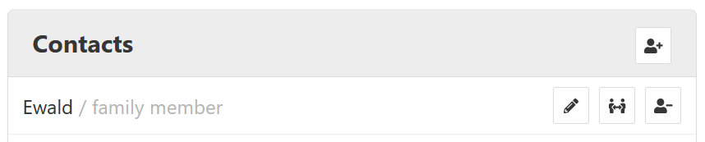
Illustration 5: contact options, as soon as the curser lands on a contact

Press the button "Remove contact" to remove a contact and delete it from the list.

Editing relationships of contacts

Next to the icon "Edit contact" is the icon "Edit relations of contact". Click on this icon to open a field where you can enter connections to other contacts. If you select names under the column "Possible contacts", these are moved to the column "Connected contacts" and connections are created in the graphic. If you want to disconnect a connection, click on the name in the "Connected contacts" column and the person is moved back to the left to the "Possible contacts". Another option is to click on the node of another contact to create or break a connection between these two contacts.
The entry of connections works across persons: If a connection to person B is drawn for person A, this connection also appears under the relationships of person B.
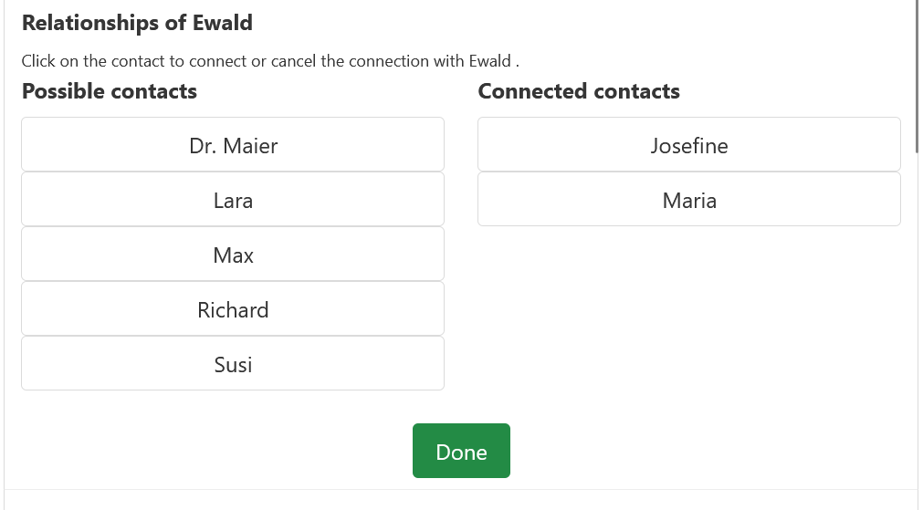
Illustration 6: Overview of relationsships

Click on "Done" to save the data and close the field.

Quick creation of contacts in the graphic
If you only want to add contacts to the graphic at first and add information later, there are two quick methods to do this.
Double-click on an empty position in the graphic to start adding a contact and define its position. Enter the name directly using the keyboard. Double-clicking on the position of this contact completes the adding process.
After clicking on "Add contact", the mouse can remain over the graphic to define the position, while the name of the person is entered with the keyboard. Pressing the Enter key saves the contact and opens a new edit field for the next contact. Other form fields can be reached with the tab key. You could type the name with one hand while the other hand remains on the mouse. Click on "Edit contact" if you want to add more information later.

Saving and Opening

Saving a network map
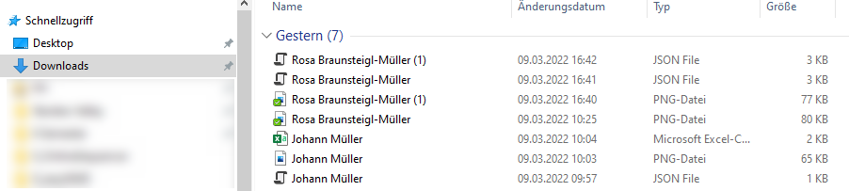
To save a NWK, click on the "Save" button in the menu (top left). A .json file with the name of the ego is then downloaded. The file can be found in the file explorer in the download folder. If needed, the file can be moved from there to another folder.
Illustration 7: files are being saved locally in your downloads folder

Attention: When the .json file is opened in the web browser or file explorer by clicking on it, the data it contains is displayed in a format structured for computers, which is only useful for humans in exceptional cases. To open the NWK again, proceed as described in the next section.

Opening a Network Map
If you want to open an existing NWK on the website, you do this by clicking on the button "Open" in the menu (top left). Activating the button opens the file explorer where the appropriate file can be selected. (If a downloaded file has not yet been moved manually, it is located in the download folder by default). Opening a network-map is only possible with files ending in .nwk or .json. If "Open" is being clicked, the window closes and the NWK was successfully opened in the program.
However, if your file is a .nwk file make sure to encrypt it before opening. It’s easily done by opening your file in e. g. Notepad++, now go to the tab called Encoding and choose ‘windows-1252’. Finally, save your encoded file and you will be able to open the file in easyNWK.
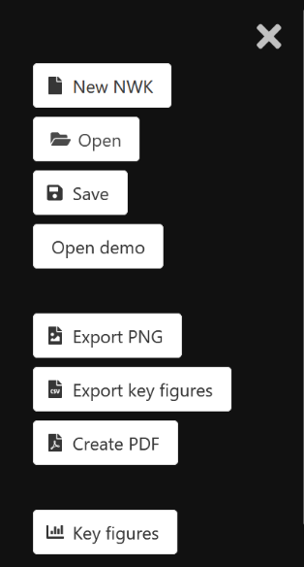
Attention: The previously entered data will be replaced during the opening process. If required, you should save the data beforehand.
Illustration 8: unfolded menu

Load Demo
The "Load Demo" button opens a demo of the fictitious ego Rosa-Braunsteigl-Müller.

Print / Save as PDF
In the menu (top left) you will find the option "Create PDF". This opens a print view of the contacts and the current network map in a new browser tab and directly activates the print function.

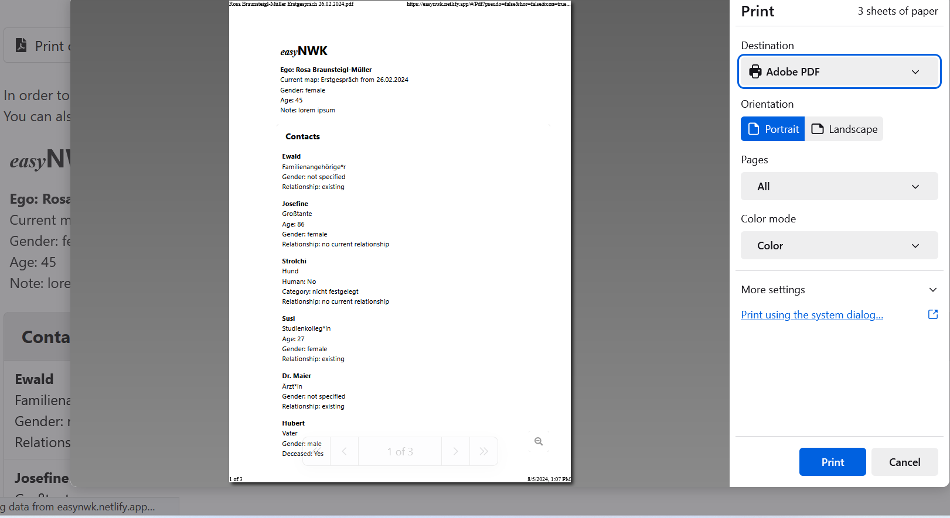
Illustration 9: Firefox Browser print window “create PDF”

In the print function of many web browsers (e.g. Chrome, Firefox) there is also the option to save the pages in a PDF.
The print view can also be used to copy all captured data of the contacts into other documents.

Export
There are two different export options in the menu: "Export PNG" and "Export key figures". Export PNG" downloads an image file containing the graphic of the current NWK. "Export key figures" starts the download of a CSV file with all important key figures, which can be opened with MS Excel, for example. Both of these files can be found locally in the download folder.

Key figures
Statistical evaluations and key figures can be displayed in the menu (☰ top left) with the button "Key figures". This opens a table under the list "Contacts" with the heading "Key figures".
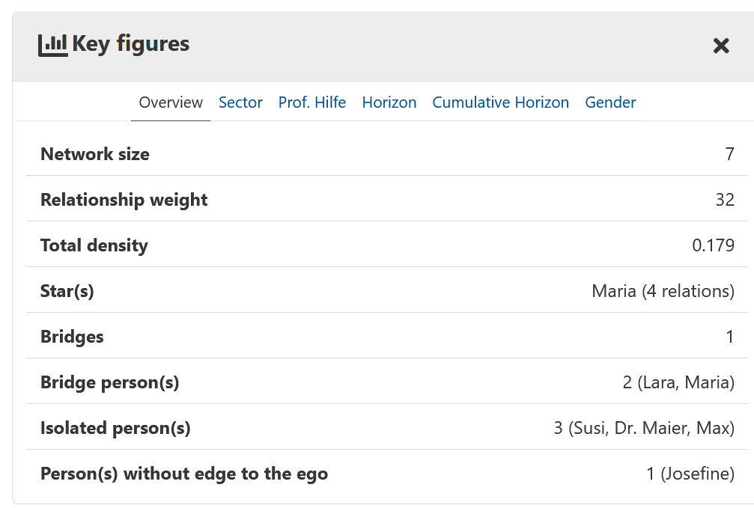
Illustration 10:Overview key figures

You can switch between different evaluation categories using the heading:

Overview | Key figures for the entire network map
Sector | Comparison of family, friends/acquaintances, colleagues, prof. helpers
Prof. help | Comparison of prof. helpers, remaining network, entire network
Horizon | Comparison of circle 3 (closest contacts), circle 2, circle 1 (weak ties)
Horizon (cumulative) | Comparison of circle 3, circle 3+2, circle 3+2+1
gender | Comparison of female, male, diverse and not determined

The following key figures are calculated:
Key figure | Value range | Interpretation guide
Network size | Integer | Section 4.1
Relationship weight | Integer | Section 4.3
Density | Number betw. 0 and 1 | Section 4.2
Star(s) | Contact(s) | Section 4.6
Bridges | Integer | Section 4.6
Bridge person(s) | Contact(s) | Section 4.6
Isolated person(s) | Contact(s) | Section 4.6
Person(s) without edge to the ego | Contact(s) | Section 4.6
To hightlight those identified as Star(s), Bridge Person(s), Isolated Person(s) or Person(s) without Edge to ego in the graph, click on their entry in the Key Figures.

View settings
All view settings in the menu are briefly explained here.
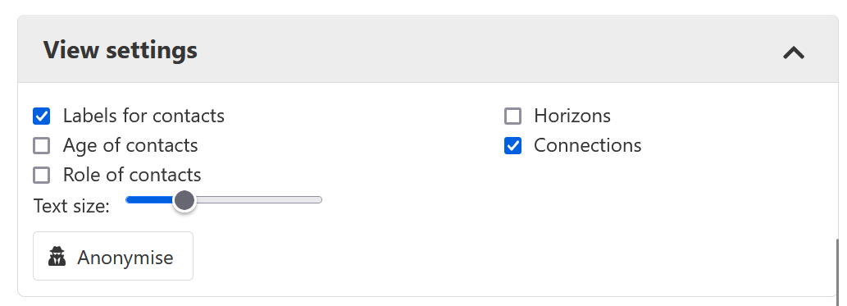
Illustration 11: opened window „View settings”

Labels for contacts
The tick-box "Labels for contacts" hides or shows all names or abbreviations in the graphic. The current setting is retained in the exports. In contrast to anonymising, however, the names of the persons are retained when saving and are not lost.

Age and Role of contacts
With the two optional tick-boxes right below “Labels for contacts”, the pre-assigned age and role of the contacts can be displayed by demand.

Horizons
If you tick the box “Horizons”, green horizons can be shown or hidden on the map. Horizons will not be visible in image-files, if the graphic has been exported without horizons.

Connections
Depending on if you tick the “Connections”-box or not, connecting lines can be made visible or invisible in the graphic. Same principal applies, current settings are being transferred if a PNG-export is being performed.

Text size
The bar to adjust the text sizes is located right next to the word-box “text size”. Text size is increasing from left to right and is either selected by a simple klick on the bar or if you press down and drag the circle to a suitable size.

Anonymise
If you do not want to display the names of contacts in an NWK, use the "Anonymise" button. This replaces all names, both in the contact list and in the graphic, with abbreviations that reflect the relationship to the ego. If you click on the button again, which is now called "De-anonymise", all names are displayed again.

Attention: If an NWK is saved in anonymised mode, only the abbreviations are saved. The original names cannot be restored. If a complete NWK including the original names is to be archived, it should be saved again after de-anonymisation.

The selection rectangle

Selection an area
An area is highlighted by pressing the left mouse button over the network card and dragging the mouse until the desired area is selected. This selection rectangle is displayed in grey and can now be moved freely across the map.
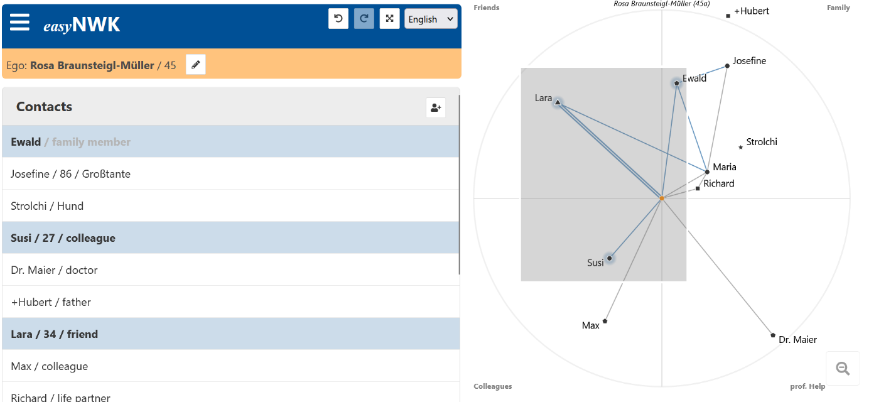
Illustration 12: A selected rectangle

The button 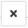 closes the selection rectangle again.

Creating cliques
To create cliques, i.e., to connect all nodes in an area with edges, the desired area must first be marked (see section 7.1). To create a clique, press the white button in the upper left corner.

Zooming
There are three different ways of zooming:
First, mark the desired area (cf. section 7.1). The button "Zoom" enlarges the marked area to the entire graphic area.
The second way to zoom is to turn the mouse wheel.
Different sectors can be enlarged by clicking on the title of the sector, e. g. family.
To exit every Zoom, simply press the Reset-Button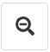, located on the bottom right.

Maps and versions
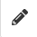
The menu point maps and gradients provides the ability to open a new empty map, to duplicate or to change maps. In the first colon the title and creation date of your current map are located. You can easily edit them by using the pencil-icon next to them.

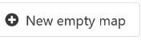
New empty map
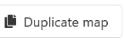
New empty map can provide you with an untouched and brand-new version of your map. In contrast to the burger menus “New NWK”-icon, the ego remains untouched. In addition, it provides the possibility to switch between maps. (see 8.3)

Duplicate map
The duplicate map icon allows you to receive an exact copy of the current map. After that you may edit and update the map in every way needed or wanted without causing altercations to the original map.

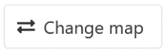
Change map
To switch between maps a yellow bar with dots will appear above your map. The dots are titled after the maps they are representing, except if you didn’t name your map, then the creation date will appear instead.

Storage location and data protection
The easyNWK 2 is realised as a web application. This means that when https://www.easynwk.com/ is called up, programme instructions and graphics are transferred from the web server (www.easynwk.com) to the web browser (e.g. Chrome, Firefox). These programme instructions are executed in the web browser, i.e. on the local device (e.g. notebook, tablet), so that the NWK can be filled and evaluated.

The entered data of the ego and the contacts are temporarily stored in the web browser in the so-called LocalStorage. There is no transmission of this data to servers or other devices.

This means:
Data protection precautions are limited to the device used and where stored or exported data is archived (analogous to a normally installed programme).
Network maps cannot be synchronised directly between different devices, but must be stored, transferred and opened.
There are no automatic backup copies of the network cards on www.easynwk.com or elsewhere.

When the work on a network map is finished and necessary data is stored, we recommend deleting the data in the web browser by creating a "New NWK" and closing the browser tab. Alternatively, the locally stored data can also be deleted via the menus of common web browsers.

easyNWK 2 is an open-source software whose programme instructions can be found at https://github.com/fhstp/easynwk-web or can also be operated by a separate web. In this case, the imprint link must be changed.

Annex English

Project TransSoDia
The creation and expansion of this document were promoted by:
Federal ministry for employment and economy with their initiative “Digital Innovation Hub in Österreich” as well as the county of lower Austria (lower Austria’s economic and tourism funds)
https://research.fhstp.ac.at/projekte/dihost-digital-innovation-hub-noe-wien-burgenland
In the project TransSoDia - Teaching and learning cooperative social diagnostics transnationally and digitally, which is co-funded by the EU programme Erasmus+, three universities from Austria, the Netherlands and Germany have intensified their cooperation to strengthen the diagnostic skills of social work students and practitioners. Social work is a profession and discipline dedicated to combating poverty and promoting the health and well-being of people. This product is part of the information and learning materials developed in the project.
Duration: 01.04.2022 - 31.03.2025
Project Team:
University of Applied Sciences St. Pölten (AT):
- FH-Prof. DSA Mag. Karin Goger MSc MSc
- Mag. (FH) Christina Engel-Unterberger
- Dipl.-Ing. Mag. Alexander Rind
- Julia Böck BSc
Kiel University of Applied Sciences (DE):
- Prof. Dr. phil. habil. Joseph Richter-Mackenstein
Saxion University of Applied Sciences Enschede (NL):
- Christian Schwital, BA, MA

Disclaimer
The European Commission support for the production of this publication does not constitute an endorsement of the contents which reflects the views only of the authors, and the Commission cannot be held responsible for any use which may be made of the information contained therein.

Fachhochschule St. Pölten (Österreich)
Goger, K. & Ullmann, S. (2022). Leitfaden für die Erstellung und Analyse egozentrierter Netzwerkkarten. Stand: 05. Februar 2022. https://www.easynwk.com/wp-content/uploads/2022/02/NWK-Manual_20220205.pdf (abgerufen am 21.03.2022)
vgl. https://html.spec.whatwg.org/multipage/webstorage.html (abgerufen am 17.03.2022)

